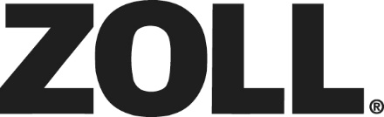
International Source Codes for Campaigns in Salesforce
What is a Source Code?
A source code is a unique identifier used to organize and track the progress of marketing campaigns inclusive of specialized landing pages, Emails, featured product detail pages, category lists, and URLs. It represents what the campaign is, whose it is, and when it was done.
Why is a Source Code Important?
It is important that everyone follows the source code convention in Salesforce.com when a campaign is entered so it is easily distinguishable as to whose it is, what it is about, and when it was done.
A Source code is made up of FIVE Parts. Example: EUHABC0423E
- The First part is made up of 1-3 letters representing the Country.
I = International or multiple regions | UK = United Kingdom | EUD = Europe distribution
DE = Germany | EU = Europe | MEA = Middle East and Africa
BNL = Benelux | FR = France | AP = Asia Pacific
IT = Italy | AU = Australia | LA = Latin America
CH = China

- The Second part is made up of letters representing the market.
E = EMS | PS = Public Safety
H = Hospital | AC = Alternate Care
TMS – Temperature Management
- The Third part is the description of the campaign or tradeshow.
  - This is a four letter (hopefully) description of the program. For example, if it was a show, give the name of the show like EMST or NTI.
- The Fourth part is the timeframe.
  - Four digits represent the time frame with two digits for the month and two for the year.
    - Example: 0614 for June 2014.
- The Fifth Part is W or E are used if it is a web banner ad or an eblast.
  - Webinars would fall under “E” for eblast

